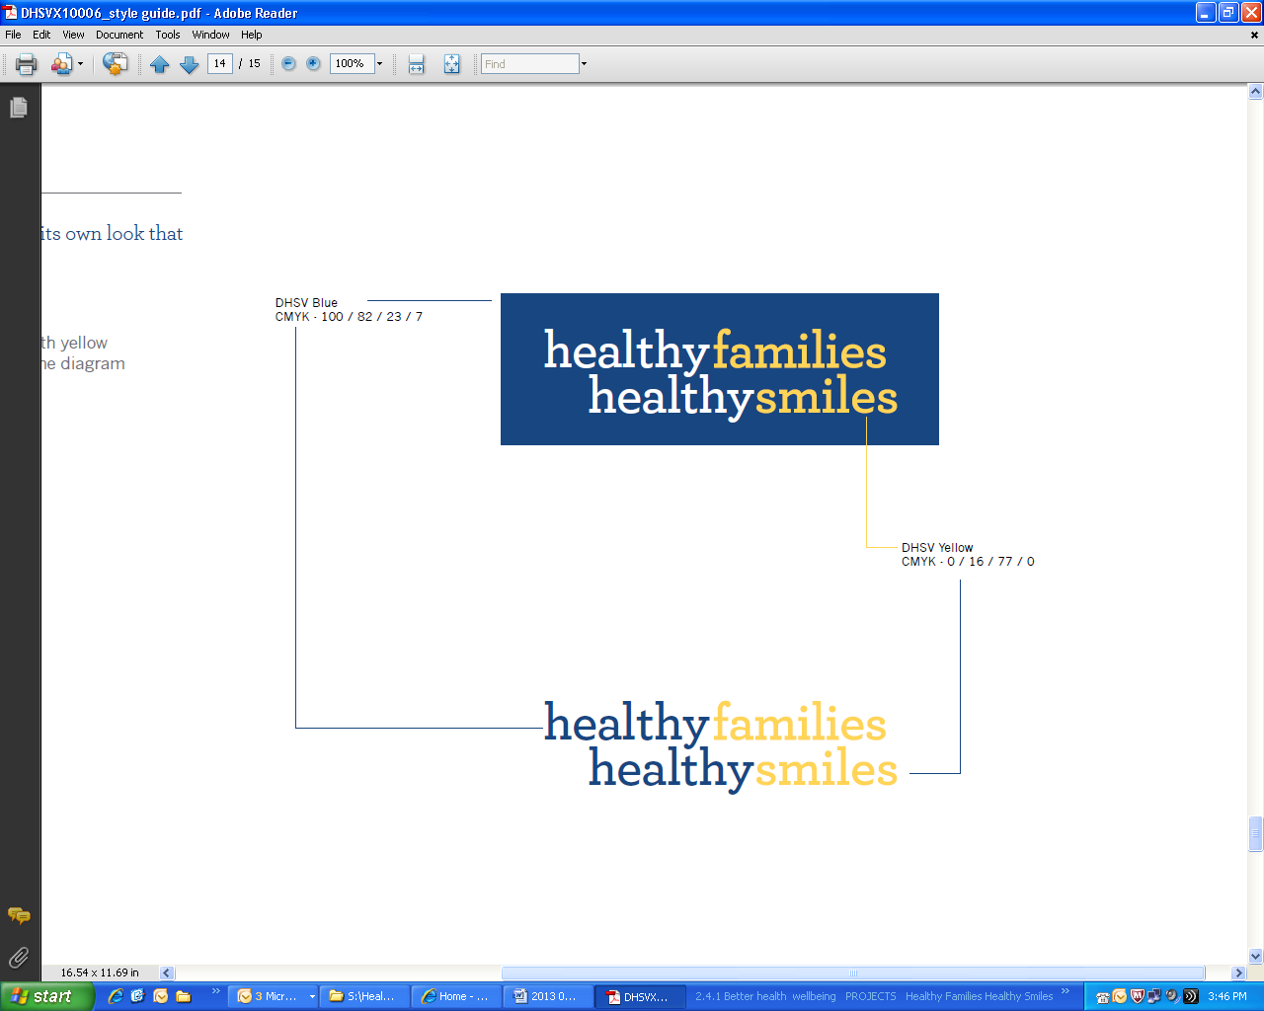

Think about how you can do this across all areas:

* Learning experiences
* Engaging families
* Professional practice and organisational policies

Action Plan

What could you incorporate into your service / your practice to improve the oral health of children?

|  |  |  |  |
| --- | --- | --- | --- |
| **Issue**  What’s happening in our service? → What do we want to happen? | **Strategy**  How could we resolve this?  What needs to be done? What can our service do? | **Examples**  See Healthy Little Smiles resource kit — page ___ | Link to NQS or EYLF |
|  |  |  |  |
|  |  |  |  |
|  |  |  |  |
|  |  |  |  |